Create an Azure Cosmos DB account, database, container, and items from the Azure portal

- Create an Azure Cosmos DB account
- From the Azure portal menu or the Home page, select Create a resource.
- Search for Azure Cosmos DB. Select Create > Azure Cosmos DB.
- On the Create an Azure Cosmos DB account page, select the Create option within the Azure Cosmos DB for NoSQL section.
- In the Create Azure Cosmos DB Account page, enter the basic settings for the new Azure Cosmos DB account.

Setting | Value | Description
Subscription | Subscription name | Select the Azure subscription that you want to use for this Azure Cosmos DB account.
Resource Group | Resource group name | Select a resource group, or select Create new, then enter a unique name for the new resource group.
Account Name | A unique name | Enter a name to identify your Azure Cosmos DB account. Because documents.azure.com is appended to the name that you provide to create your URI, use a unique name. The name can contain only lowercase letters, numbers, and the hyphen (-) character. It must be 3-44 characters.
Location | The region closest to your users | Select a geographic location to host your Azure Cosmos DB account. Use the location that is closest to your users to give them the fastest access to the data.
Capacity mode | Provisioned throughput or Serverless | Select Provisioned throughput to create an account in provisioned throughput mode. Select Serverless to create an account in serverless mode.
Apply Azure Cosmos DB free tier discount | Apply or Do not apply | With Azure Cosmos DB free tier, you get the first 1000 RU/s and 25 GB of storage for free in an account. Learn more about free tier.
Limit total account throughput | Selected or not | Limit the total amount of throughput that can be provisioned on this account. This limit prevents unexpected charges related to provisioned throughput. You can update or remove this limit after your account is created.

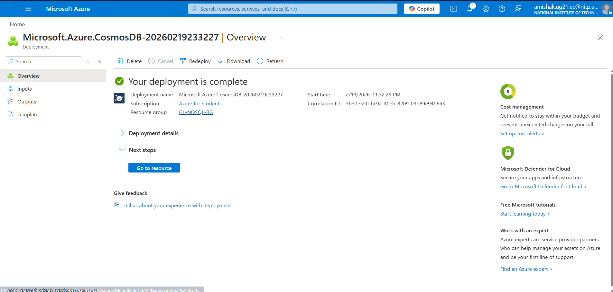
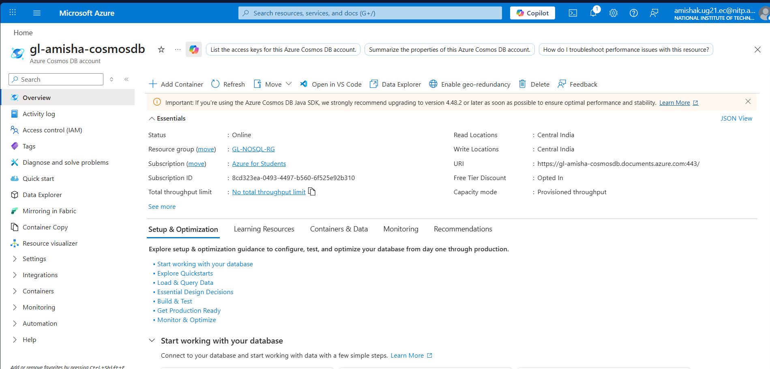
- In the Global Distribution tab, configure the following details. You can leave the default values for this quickstart:

Setting | Value | Description
Geo-Redundancy | Disable | Enable or disable global distribution on your account by pairing your region with a pair region. You can add more regions to your account later.
Multi-region Writes | Disable | Multi-region writes capability allows you to take advantage of the provisioned throughput for your databases and containers across the globe.
Availability Zones | Disable | Availability Zones help you further improve availability and resiliency of your application.

- Optionally, you can configure more details in the following tabs:
- Networking. Configure access from a virtual network.
- Backup Policy. Configure either periodic or continuous backup policy.
- Encryption. Use either service-managed key or a customer-managed key.
- Tags. Tags are name/value pairs that enable you to categorize resources and view consolidated billing by applying the same tag to multiple resources and resource groups.
- Select Review + create.
- Review the account settings, and then select Create. It takes a few minutes to create the account. Wait for the portal page to display Your deployment is complete.
- Select Go to resource to go to the Azure Cosmos DB account page.
- You can use the Data Explorer in the Azure portal to create a database and container.
- Select Data Explorer from the left navigation on your Azure Cosmos DB account page, and then select New Container > New Container.
- You may need to scroll right to see the New Container window.
- In the New Container pane, enter the settings for the new container.
Setting | Suggested value | Description
Database id | ToDoList | Enter ToDoList as the name for the new database. Database names must contain 1-255 characters, and they can't contain /, \, #, ?, or a trailing space. Check the Share throughput across containers option. It allows you to share the throughput provisioned on the database across all the containers within the database. This option also helps with cost savings.
Database throughput | Autoscale or Manual | Manual throughput allows you to scale request units per second (RU/s) yourself whereas autoscale throughput allows the system to scale RU/s based on usage. Select Manual for this example.
Database Max RU/s | 400 RU/s | If you want to reduce latency, you can scale up the throughput later by estimating the required RU/s with the capacity calculator. Note: This setting isn't available when creating a new container in a serverless account.
Container id | Items | Enter Items as the name for your new container. Container IDs have the same character requirements as database names.
Partition key | /category | The sample described in this article uses /category as the partition key.

- Select OK. The Data Explorer displays the new database and the container that you created.
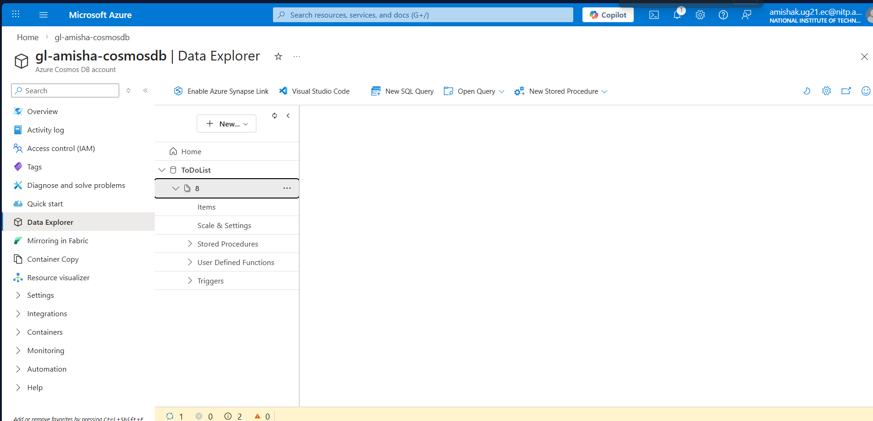
- In Data Explorer, expand the ToDoList database, and expand the Items container.
- Next, select Items, and then select New Item.
- Add the following structure to the document on the right side of the Documents pane:
{
"id": "1",
"category": "personal",
"name": "groceries",
"description": "Pick up apples and strawberries.",
"isComplete": false
}
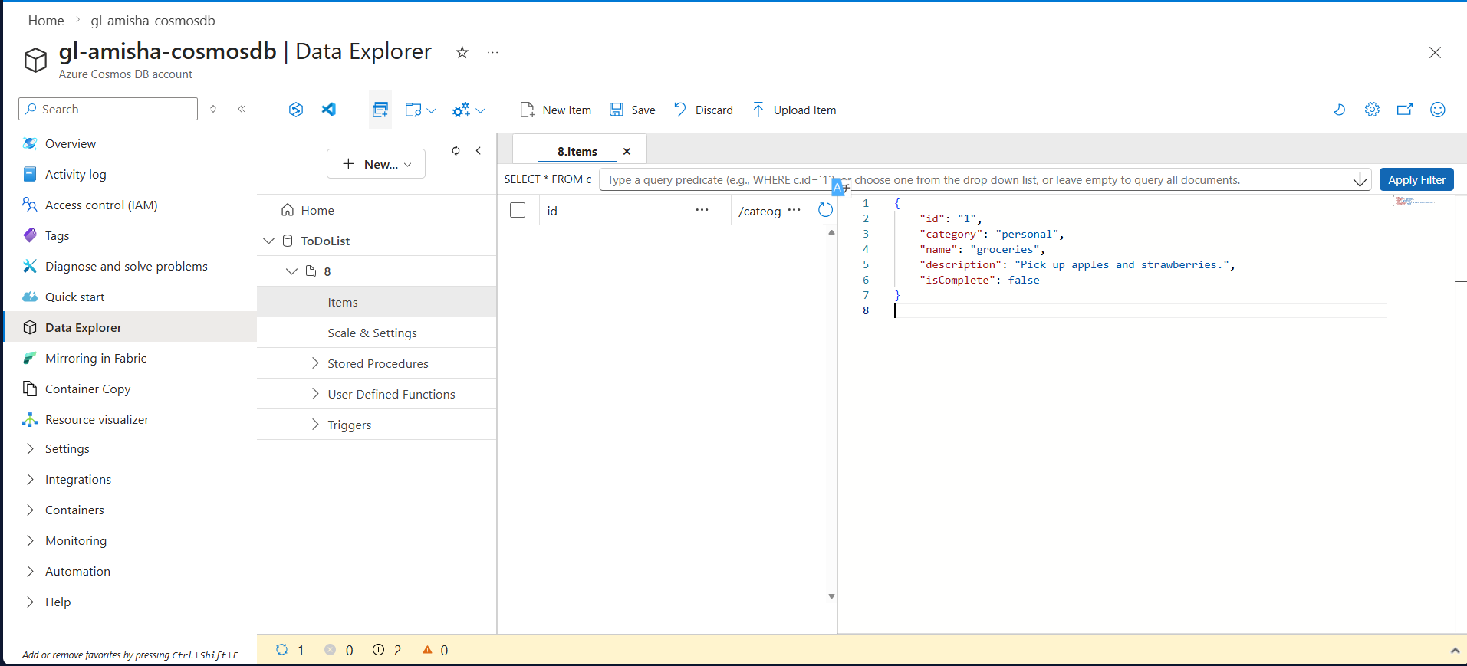

- Select Save.
- Select New Item again, and create and save another document with a unique id, and any other properties and values you want. Your documents can have any structure, because Azure Cosmos DB doesn't impose any schema on your data.
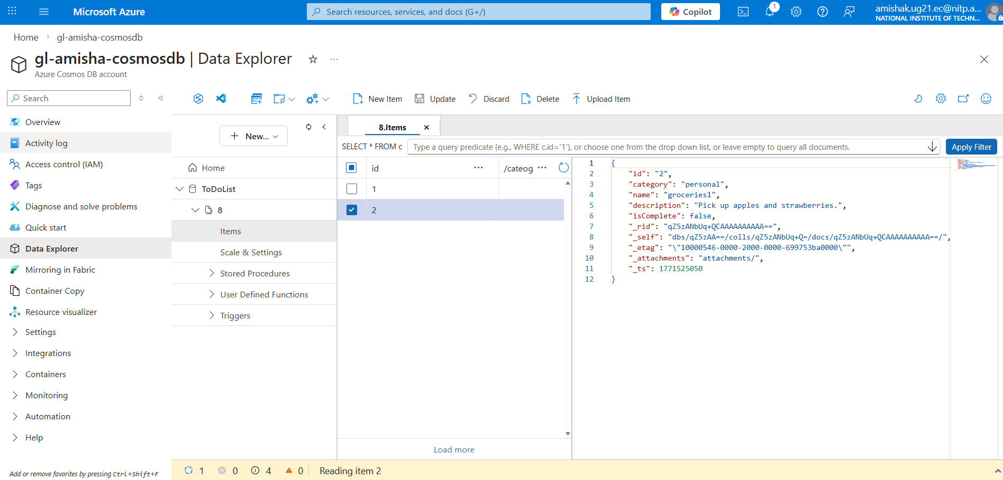
- At the top of the Items tab in Data Explorer, review the default query SELECT * FROM c. This query retrieves and displays all documents from the container ordered by ID.
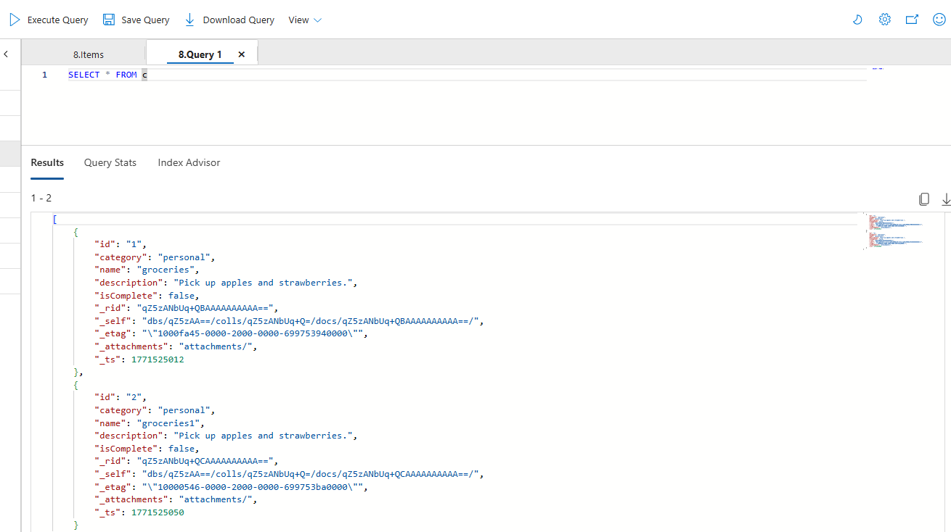
- To change the query, select Edit Filter, replace the default query with ORDER BY c._ts DESC, and then select Apply Filter.
